Ideation Phase
Empathize & Discover

Date | 03 December 2025
Project Name | Bookstore
Maximum Marks | 4 Marks

Empathy Map Canvas:
Understand the needs, frustrations, and behaviors of online book buyers and independent sellers while browsing, purchasing, and selling books on digital platforms.
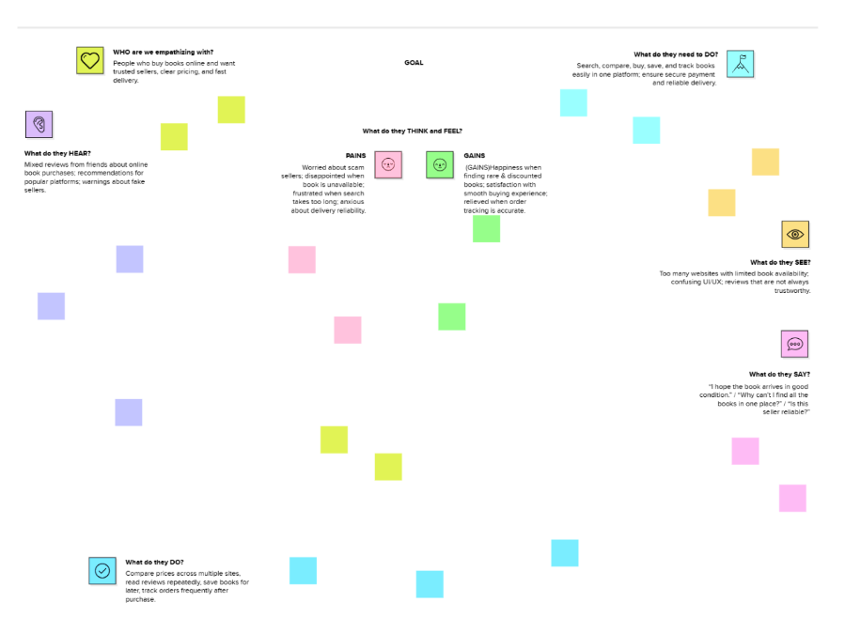

This empathy map helps us understand the behaviors, emotions, goals, pain points, and motivations of online book buyers and independent sellers. These insights guide the design of a user-centric Bookstore application.

